

Design and implement an embedded software using freeRTOS for a microwave oven with the following diagram and specifications :

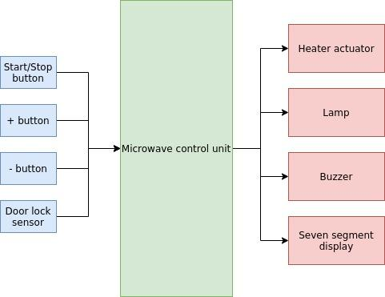

1. When it’s powered on :
   1. Buzzer beeps 100ms
   2. Seven segment display is initialized with zeros
2. When heating is off :
   1. + and - buttons are used to set the required heating time with 5 second step
   2. Lamp is
      1. on when door is open
      2. off when door is closed
   3. Seven segment displays the time setting while blinking 300ms on and 300ms off after the first change from zeros
   4. Start/stop button start heating only if door is closed
3. When heating is on:
   1. + button is used to increment the required heating time with 5 second step
   2. Seven segment displays time remaining (no blinking)
   3. lamp is on
   4. Heater is on
   5. Start/stop button stop heating
4. When heating is done:
   1. lamp is off
   2. Heater is off
   3. Buzzer beeps two times 100ms on and 100ms off
5. Buzzer beeps 100ms at each button press
6. The heater actuator requires 60% ,50ms period PWM signal in order to be turned on.
7. Use the microcontroller that you see fits the system.
8. Make any necessary assumptions and mention them in your documentation

**Deliverables**

1. Source code.
2. Project documentation illustrating:
   1. The system’s static and dynamic design.
   2. Each module and function description.